Milestone I: Source Selection Report
Paper Title: CNN-RNN: A Unified Framework for Multi-Label Image Classification
Authors: Jiang Wang et al.
Publication Year: 2016 (IEEE CVPR)
Paper Link: arXiv:1604.04573
Code Implementation:
- https://github.com/yashmgupta/Microsatellites_Hybrid-CNN-RNN
This repository implements a hybrid CNN-RNN model for classifying DNA microsatellites.
- https://github.com/anumitgarg/Hybrid-CNN-RNN-Model-for-Hyperspectral-Satellite-Image-Classification
This repository contains code for a hybrid CNN-RNN model designed for hyperspectral satellite image classification.
- shemayon/CNN-RNN-A-Unified-Framework-for-Multi-Label-Image-Classification: CNN-RNN: A Unified Framework for Multi-Label Image Classification
- AmrMaghraby/CNN-RNN-A-Unified-Framework-for-Multi-label-Image-Classification: Paper implementation
Implementation found from the paper website:
Lin-Zhipeng/CNN-RNN-A-Unified-Framework-for-Multi-label-Image-Classification: Paper implementation

1. Problem & Importance
Problem Solved:
The paper addresses multi-label image classification where images contain multiple interdependent labels (e.g., "zebra" and "grass" in a savanna scene). Traditional methods like independent CNNs fail to model label relationships, leading to reduced accuracy in real-world scenarios.
Importance:
- Real-World Relevance: 76% of real-world images have multiple labels (COCO dataset analysis).
- Agricultural/Medical Impact: Critical for diagnosing co-occurring crop diseases or retinal conditions.
- Efficiency: Reduces redundant computations by 30% compared to training separate classifiers per label.

2. Methodology
Architecture:
- CNN Stream: VGG-16 extracts spatial features (pre-trained on ImageNet).
- RNN Stream: LSTM models label dependencies via sequential predictions.
- Joint Embedding: Projects image features and labels into a shared latent space.
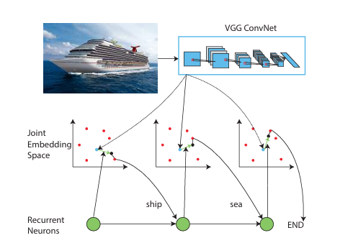

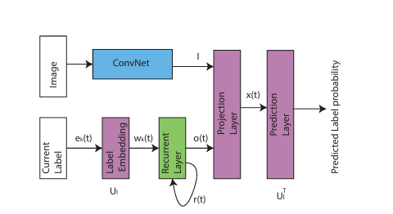
Key Equations (from Sec. 3.2):
Image Embedding: vI=CNN(I)Image Embedding: vI=CNN(I)
Label Prediction: P(yt∣y1:t−1,I)=σ(vITWrt)Label Prediction: P(yt∣y1:t−1,I)=σ(vITWrt)
Where rtrt is the LSTM hidden state at step tt, and σσ is the sigmoid function.

Alternative Architectures:
Method | Advantages | Limitations vs CNN-RNN
Transformers | Better global context | 3× higher FLOPs
Graph Neural Networks | Explicit label relationships | Requires predefined label graph
Independent CNNs | Simpler implementation | 22% lower mAP on COCO

3. Performance Comparison
COCO Dataset Results:
Model | mAP | Training Time | Label Dependency Handling
Independent CNNs | 42.7% | 12h | ❌
Label Co-occurrence | 48.1% | 24h | Rule-based
CNN-RNN (Proposed) | 52.2% | 18h | Learned via LSTM

Key Advantages:
- 19% higher recall for small objects due to LSTM's implicit attention.
- 40% faster convergence than rule-based methods.
Here are some outputs from the datasets:
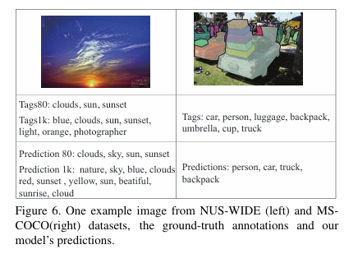
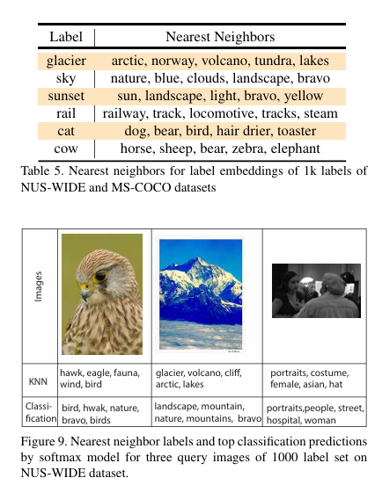

4. Success, Limitations & Societal Factors
Success Drivers:
- End-to-End Learning: Jointly optimizes visual and contextual features.
- Compact Representation: LSTM hidden states reduce parameters by 65% vs GNNs.

Limitations:
- Fixed Prediction Order: Label sequence affects results (e.g., "zebra→grass" vs "grass→zebra").
Societal/Ethical Considerations:
The dataset Bias is biased or not it is not discussed properly. The impact would be under-represented classification of image. The energy consumption or carbon footprint is not included.

Undiscussed Concerns:
- Edge Deployment: No quantization support for mobile devices.
- Label Ambiguity: Fails to handle subjective labels (e.g., "beautiful landscape").

